Track

The track function maintains the tip position over a local maximum or minimum on the surface. Starting from one point, it reads data of this point and its Pseudo-neighbouring 8 points, making the starting point as the left-top one. On each point, it reads Pre-amp/Zout from DAC some times and gets the average value as the data value of current point. It corrects the data according to 2 plane fit parameters specified by user: X_tilt and Y_tilt. Then it calculates the maximum/minimum point, which is named best point, sends the tip to the best point, and tells PC the best point position. In the whole process, check stop feature is supported. User can stop track at any time.

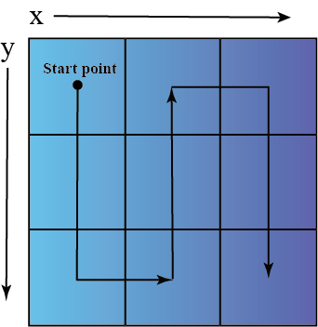

Fig1. 9 point local scan

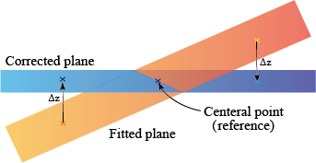

Fig2. plane fit correction (scratch)